Figure Comparison Report
Study XXX (YYY) | IND ZZZZZZ, Seq. NNNN
Left: figures as embedded in the original report. Right: figures regenerated by running the verbatim report code against the source XPT data.
The discrepancy is caused by a visit-ordering bug: pandas groupby returns visit labels alphabetically ("Week 12" before "Week 2"), so the x-axis positions assigned by VISITS.index() are out of sequence, producing scrambled line charts.

Section 3 — ADAVCG | Figure 1: L1: Avg Daily % Time <70 mg/dL | CGM-Stratified
Original Report Figure | Code-Regenerated Figure (Verbatim)
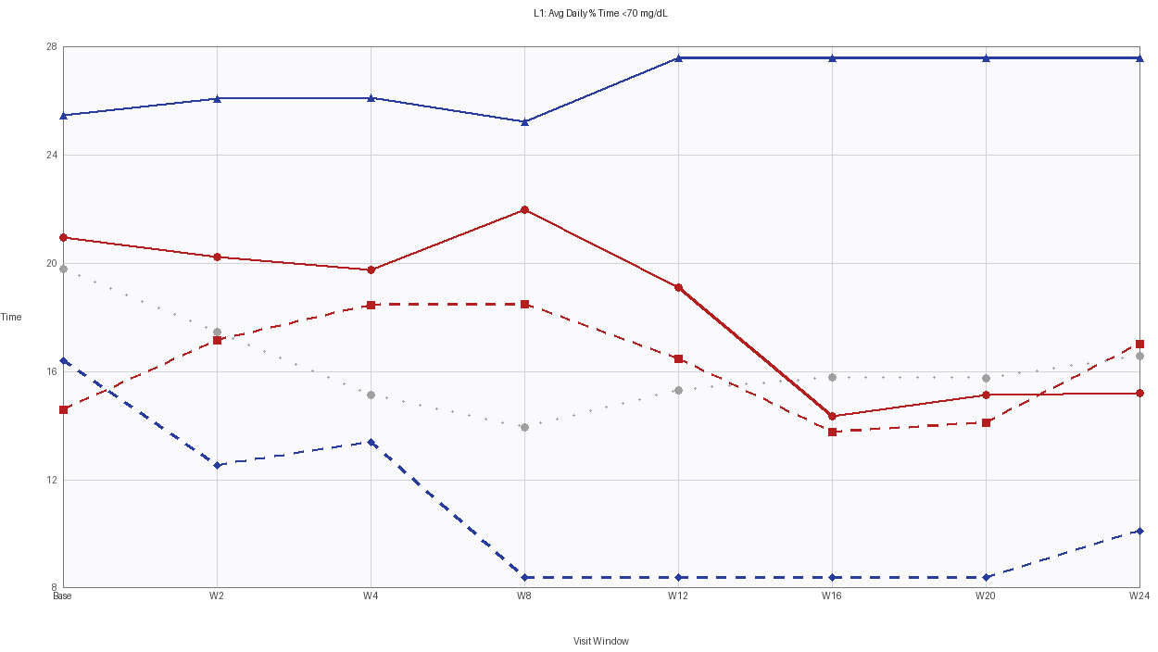 | 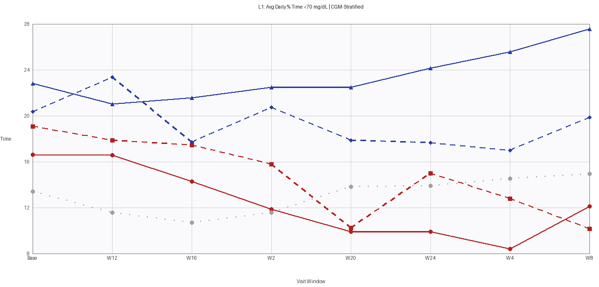

Section 3 — ADAVCG | Figure 2: L2: Avg Daily % Time <54 mg/dL | CGM-Stratified
Original Report Figure | Code-Regenerated Figure (Verbatim)
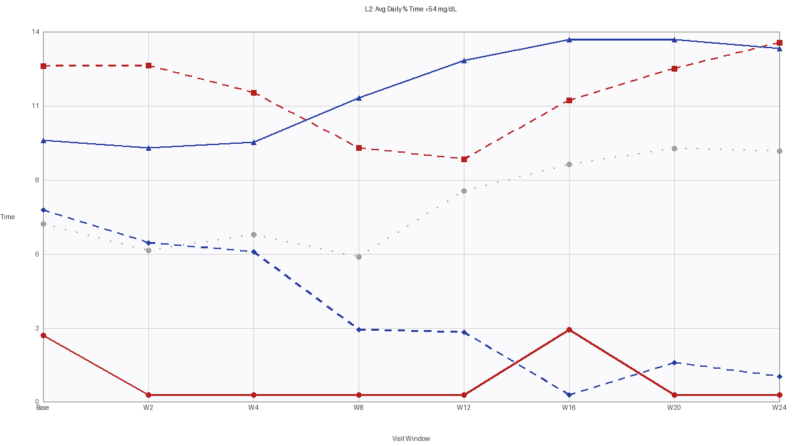 | 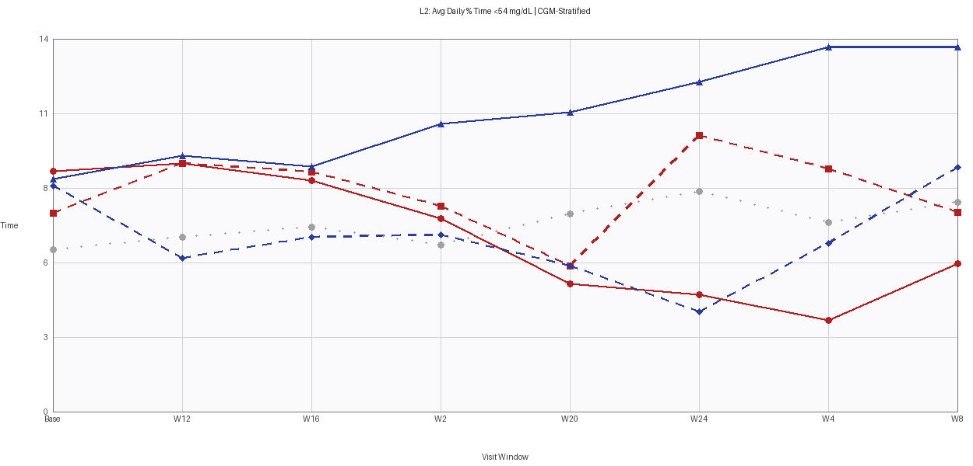

Section 3 — ADAVCG | Figure 3: 70-180 mg/dL: Avg Daily % Time | CGM-Stratified
Original Report Figure | Code-Regenerated Figure (Verbatim)
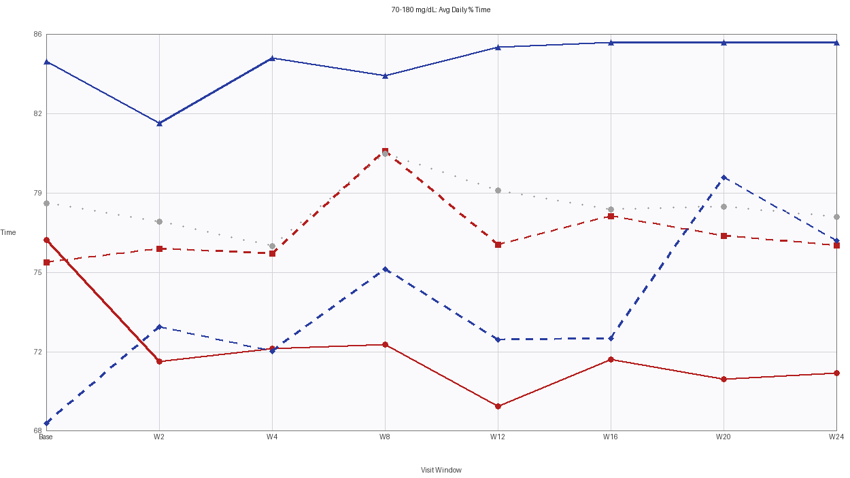 | 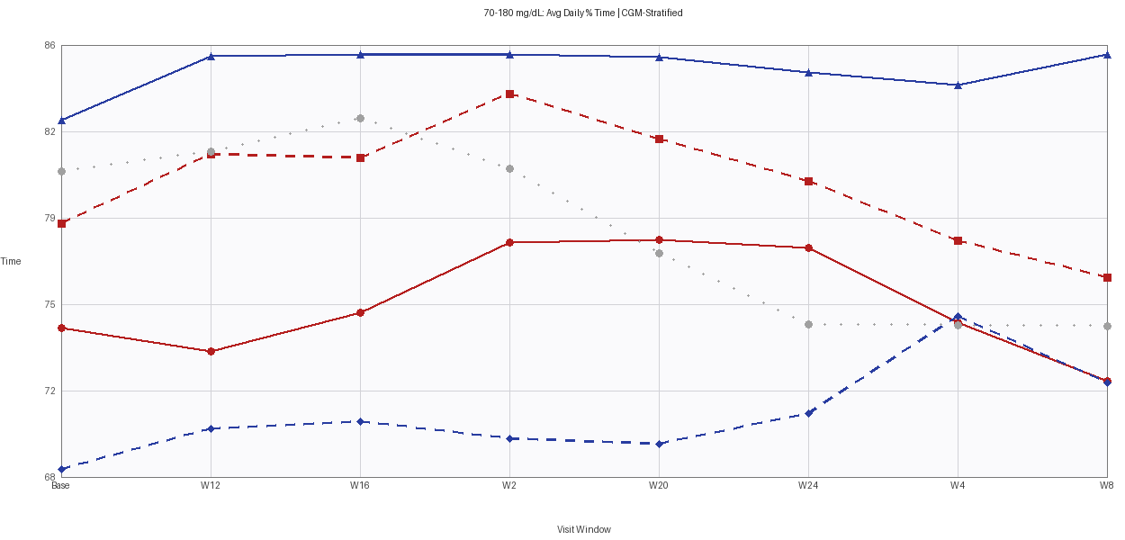

Section 3 — ADAVCG | Figure 4: CGM Average Glucose (mg/dL) | CGM-Stratified
Original Report Figure | Code-Regenerated Figure (Verbatim)
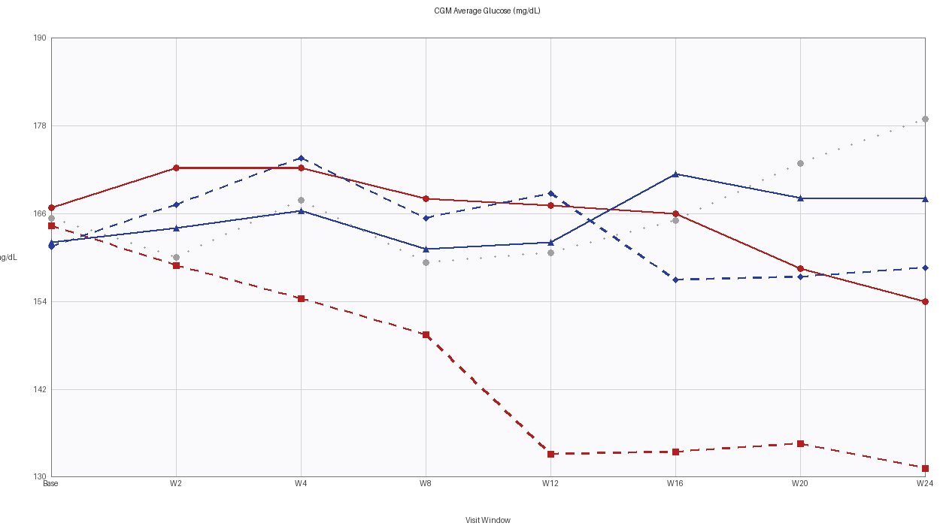 | 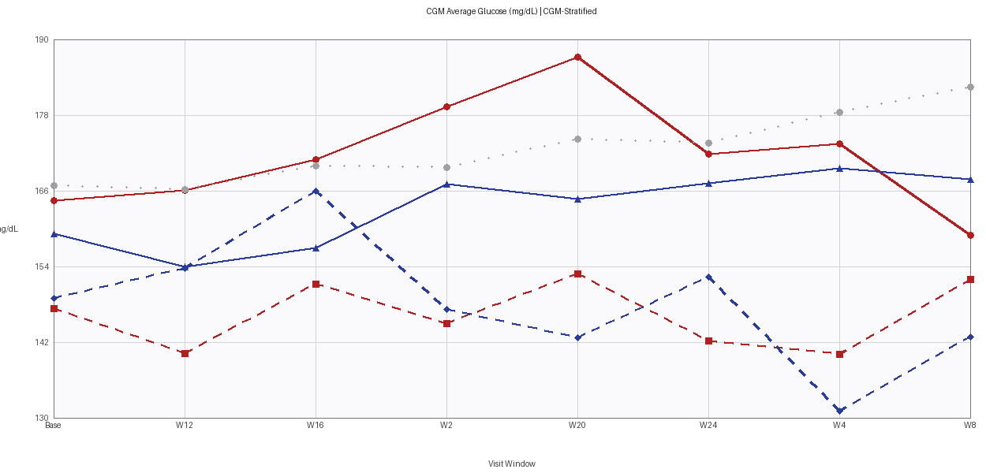

Section 3 — ADAVCG | Figure 5: Avg Daily AUC at Hypoglycemia Threshold 54 mg/dL | CGM-Stratified
Original Report Figure | Code-Regenerated Figure (Verbatim)
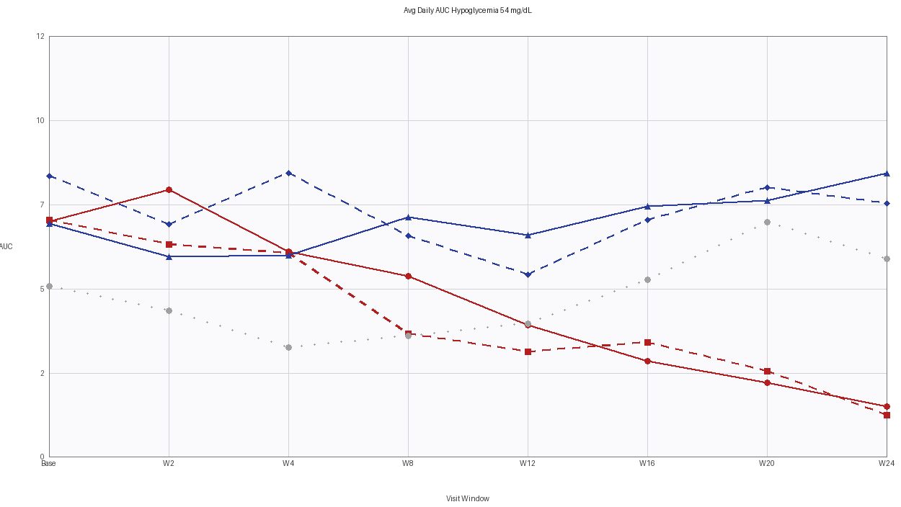 | 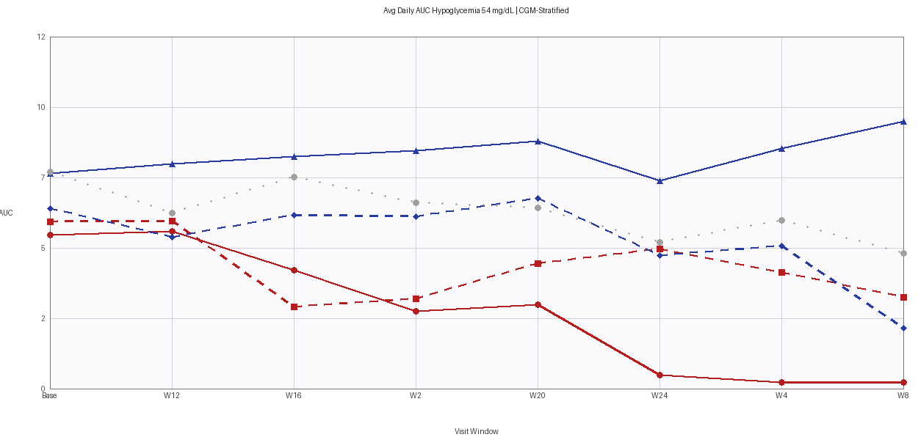

Section 3 — ADAVCG | Figure 6: Avg Daily AUC at Hypoglycemia Threshold 70 mg/dL | CGM-Stratified
Original Report Figure | Code-Regenerated Figure (Verbatim)
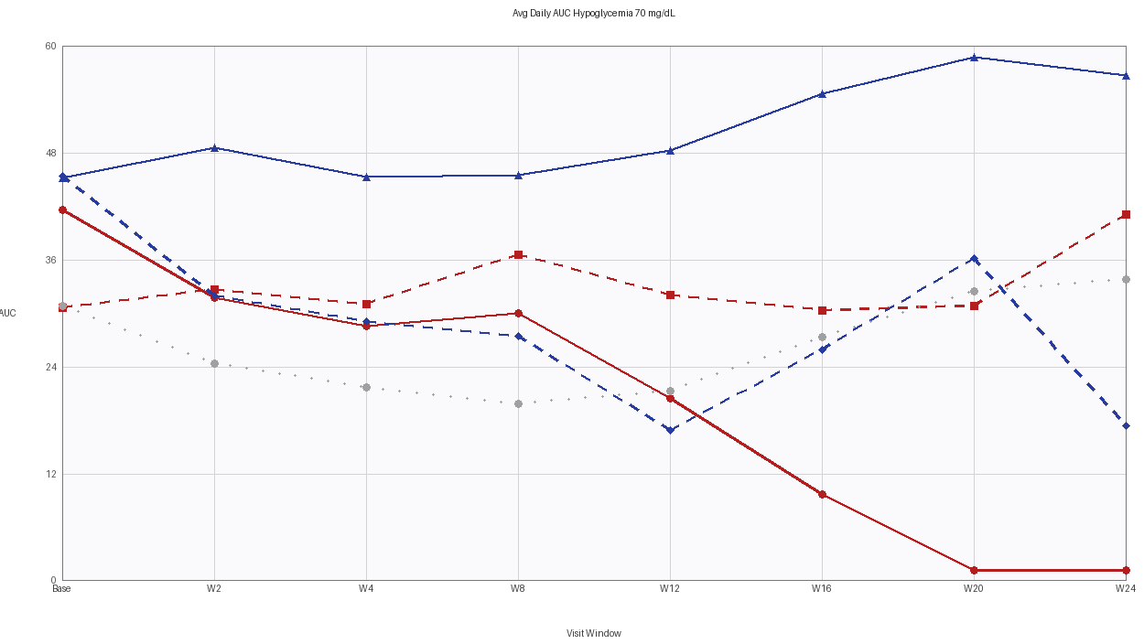 | 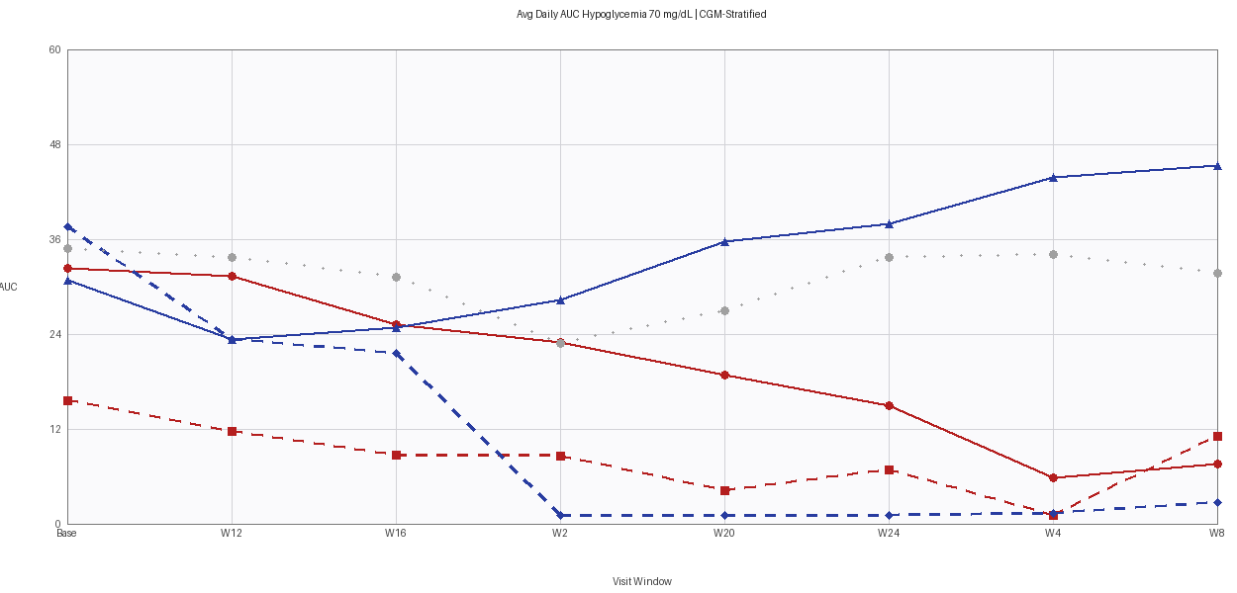

Section 3 — ADAVCG | Figure 7: Avg Daily AOC at Hypoglycemia Threshold 54 mg/dL | CGM-Stratified
Original Report Figure | Code-Regenerated Figure (Verbatim)
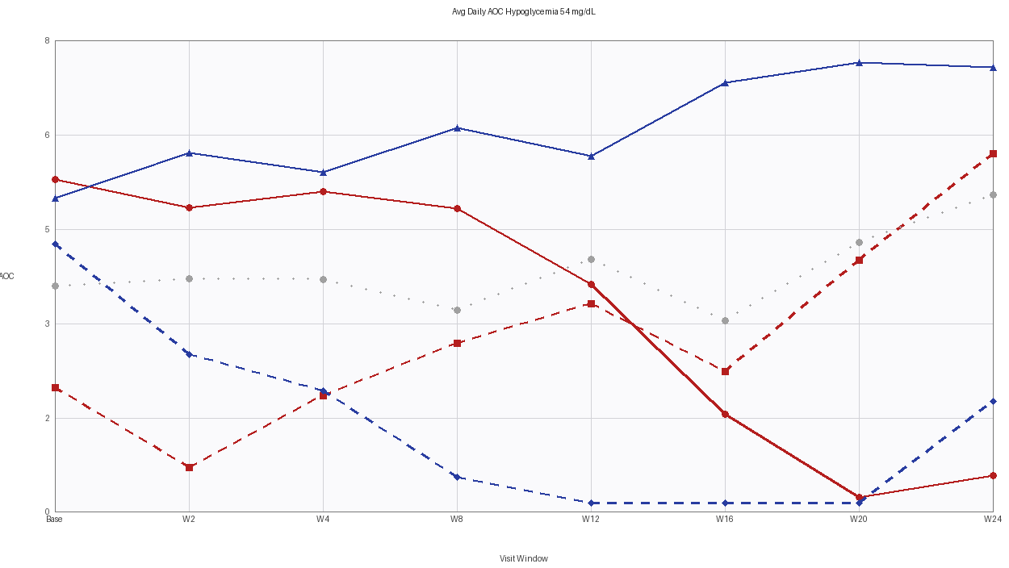 | 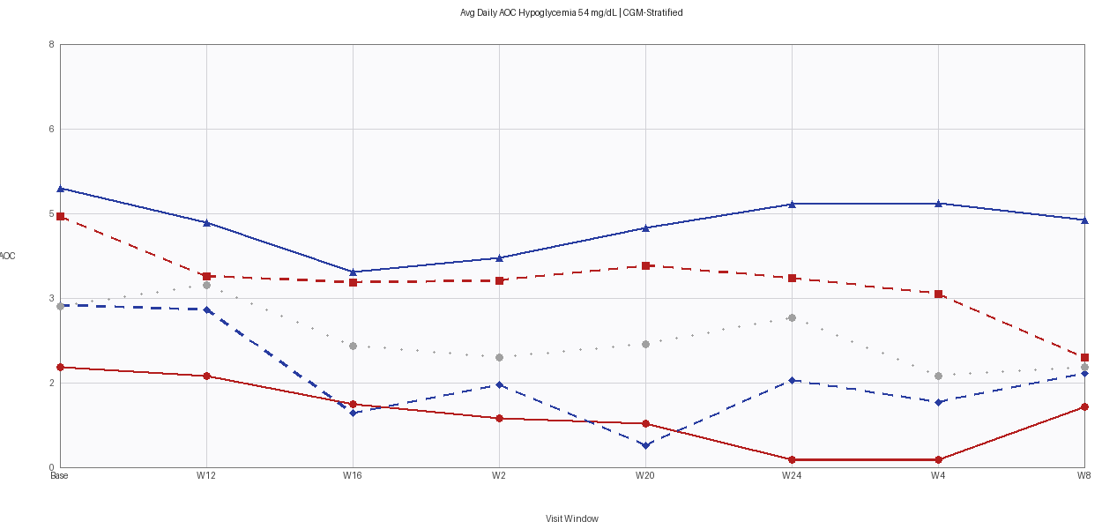

Section 3 — ADAVCG | Figure 8: Avg Daily AOC at Hypoglycemia Threshold 70 mg/dL | CGM-Stratified
Original Report Figure | Code-Regenerated Figure (Verbatim)
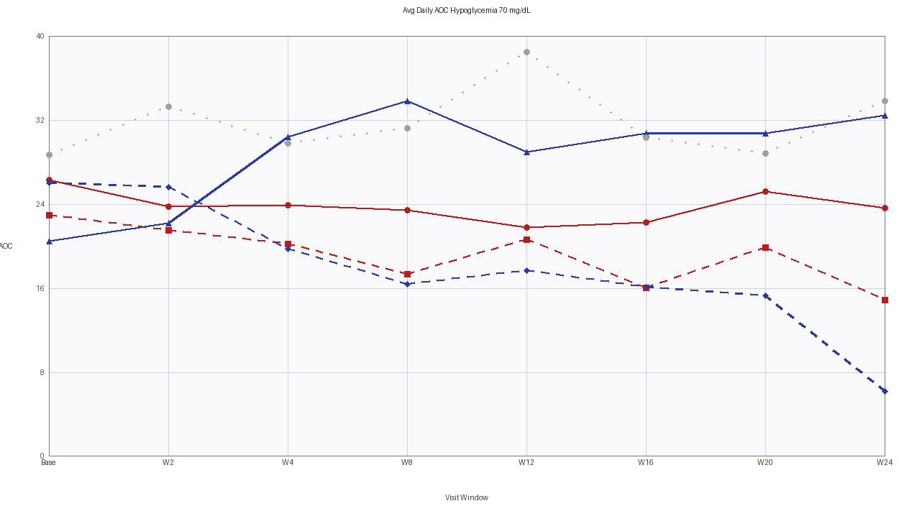 | 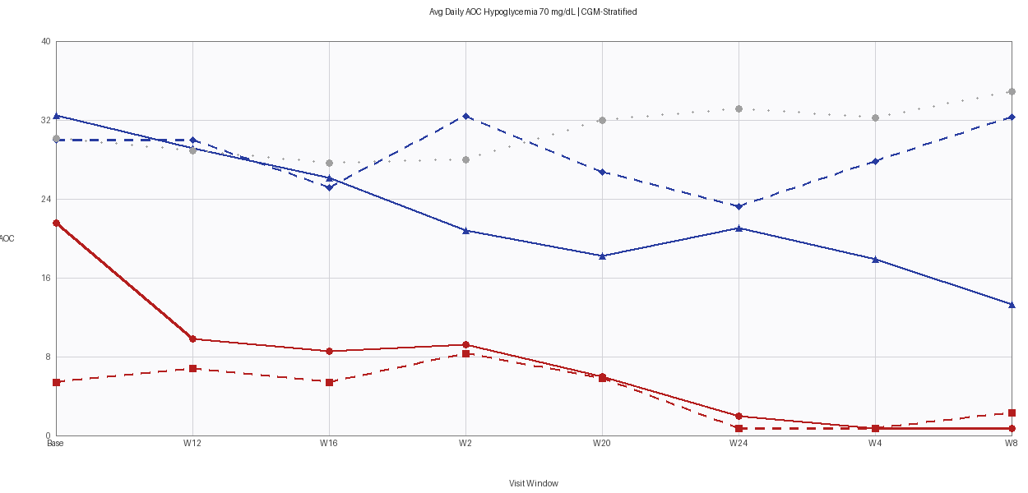

Section 3 — ADAVCG | Figure 9: L1: Avg Daily Time (Min) <70 mg/dL | CGM-Stratified
Original Report Figure | Code-Regenerated Figure (Verbatim)
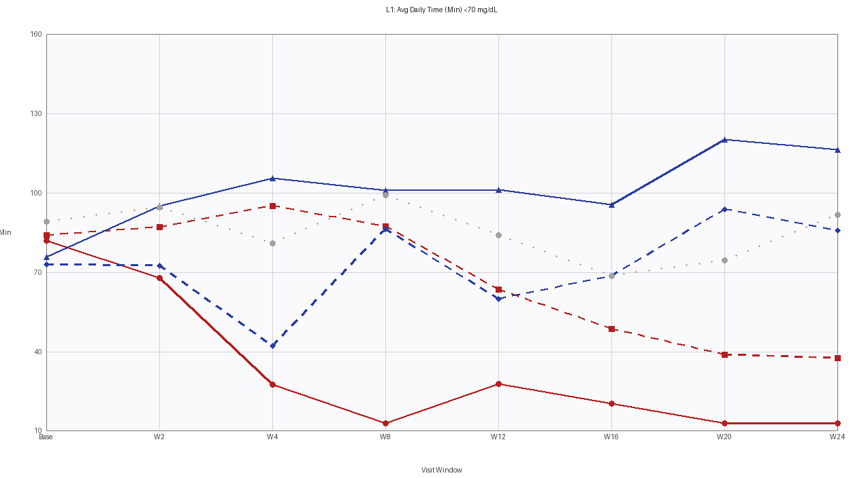 | 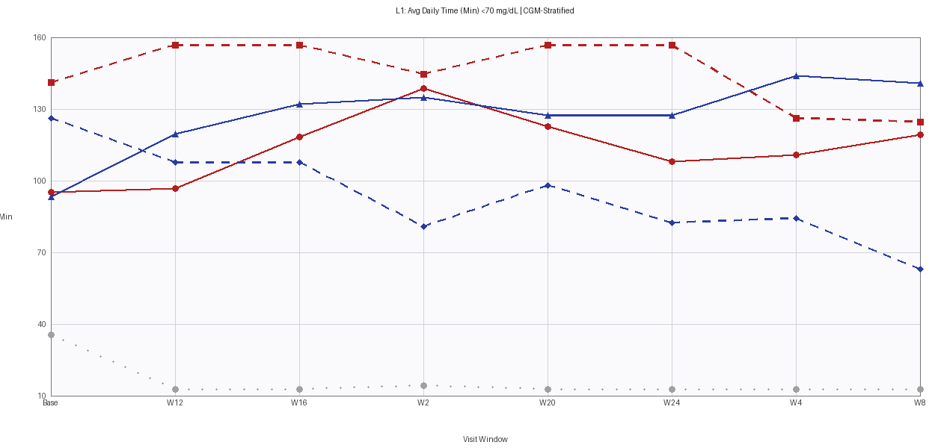

Section 3 — ADAVCG | Figure 10: L2: Avg Daily Time (Min) <54 mg/dL | CGM-Stratified
Original Report Figure | Code-Regenerated Figure (Verbatim)
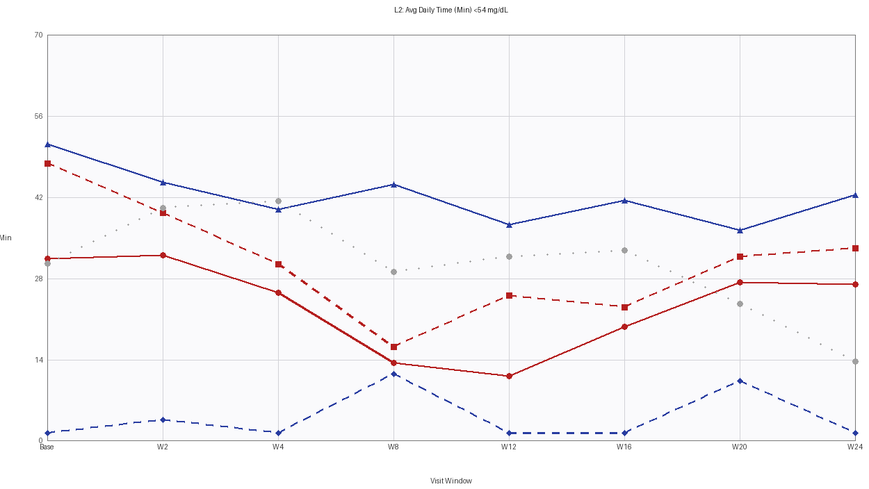 | 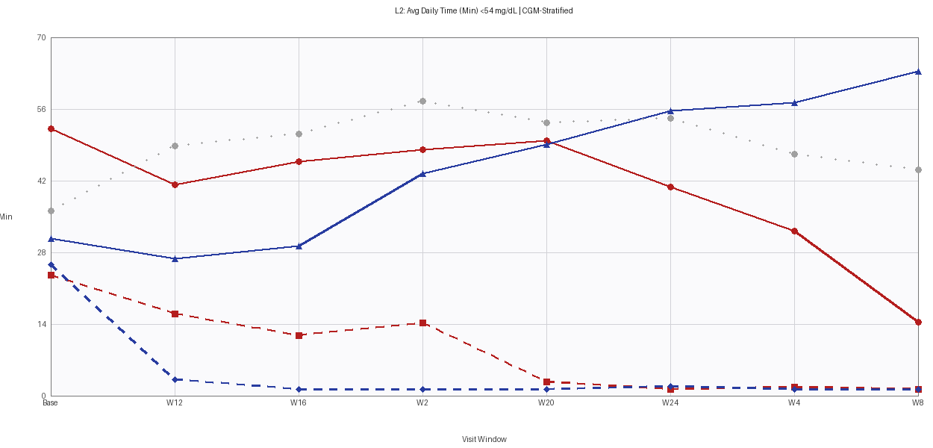

Section 3 — ADAVCG | Figure 11: CGM Data Capture Percent | CGM-Stratified
Original Report Figure | Code-Regenerated Figure (Verbatim)
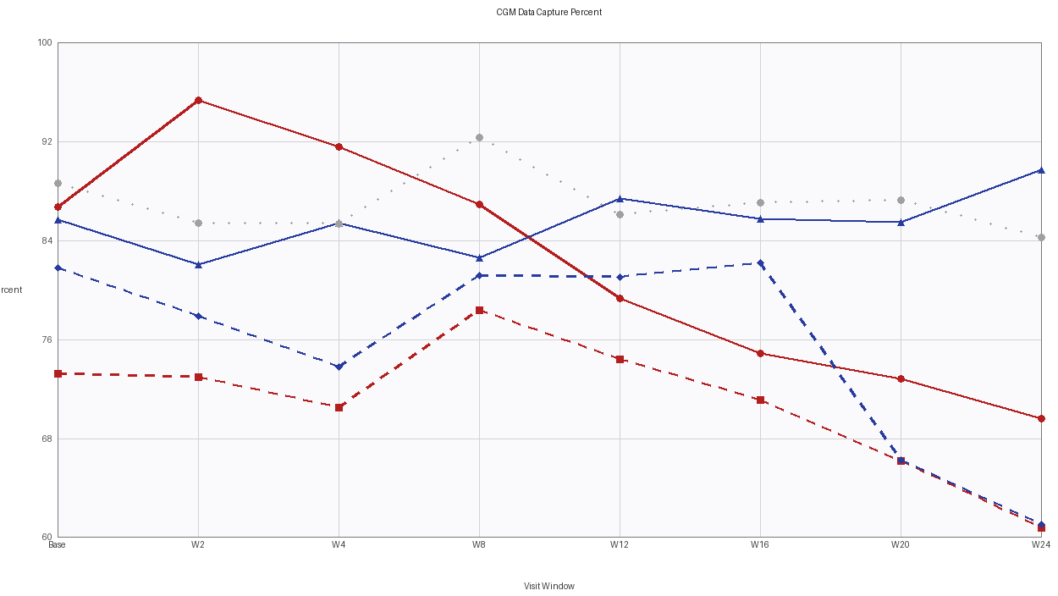 | 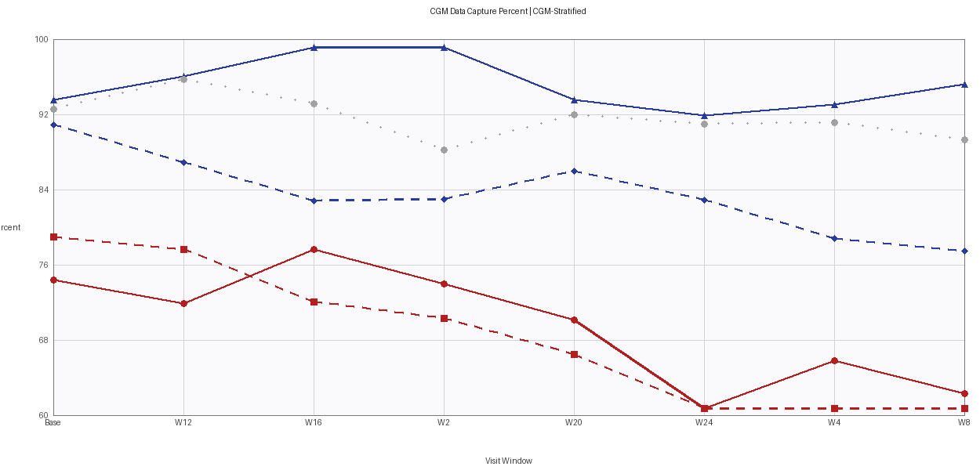

Section 3 — ADAVCG | Figure 12: L1: CGM Avg Weekly Rate 30 Min (<70 mg/dL) | CGM-Stratified
Original Report Figure | Code-Regenerated Figure (Verbatim)
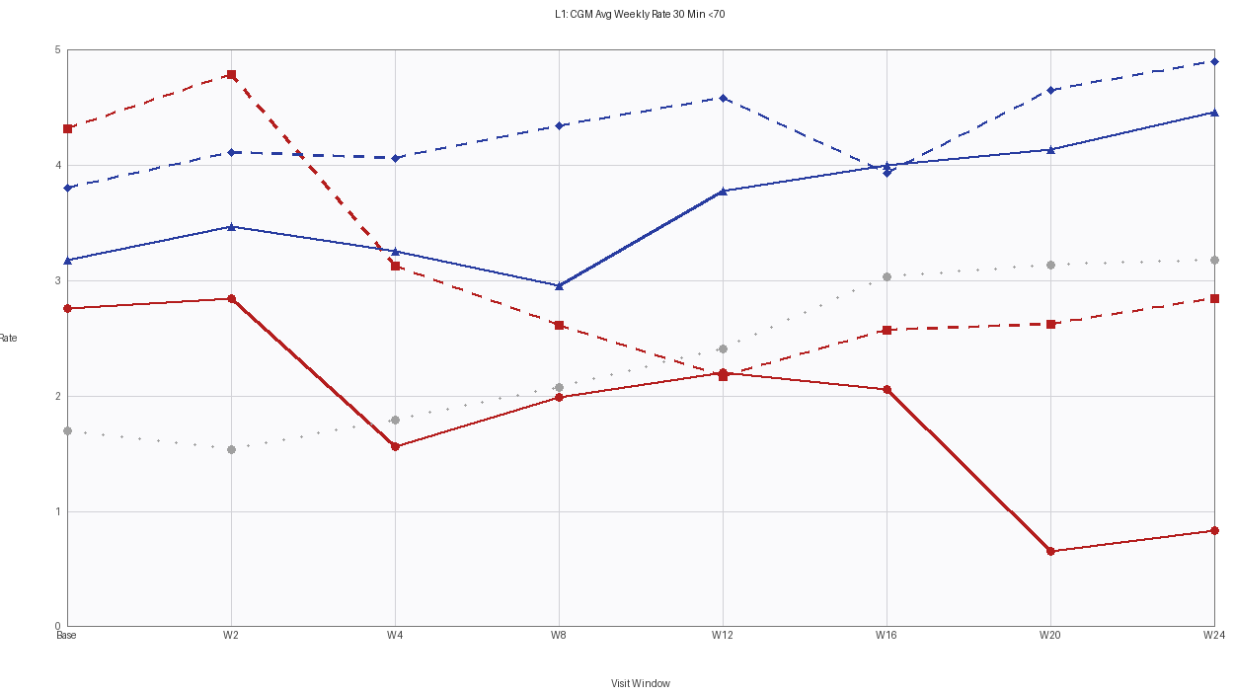 | 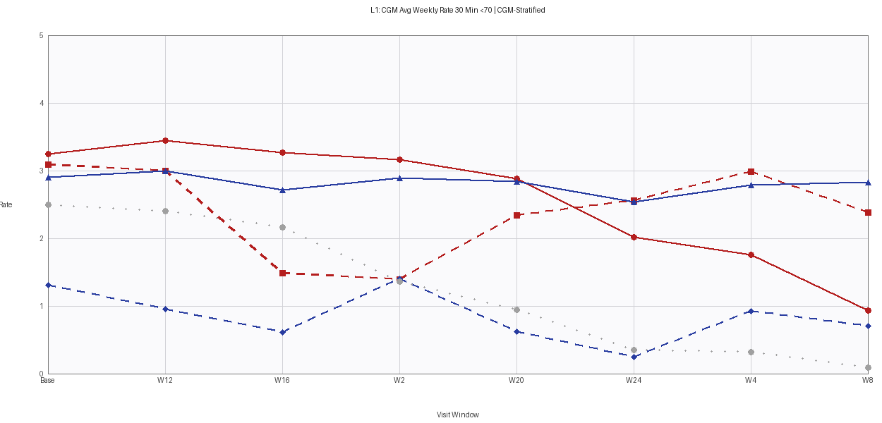

Section 3 — ADAVCG | Figure 13: L1: CGM Avg Weekly Rate 60 Min (<70 mg/dL) | CGM-Stratified
Original Report Figure | Code-Regenerated Figure (Verbatim)
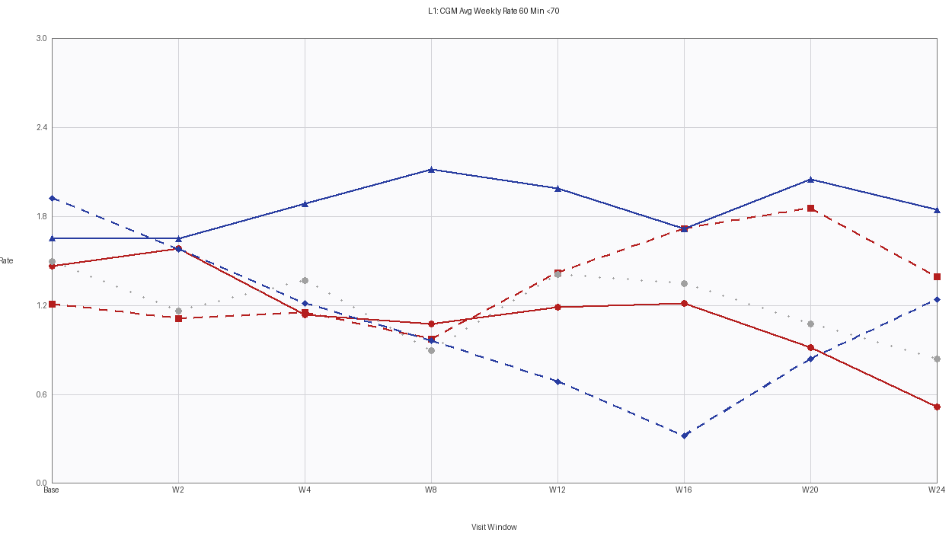 | 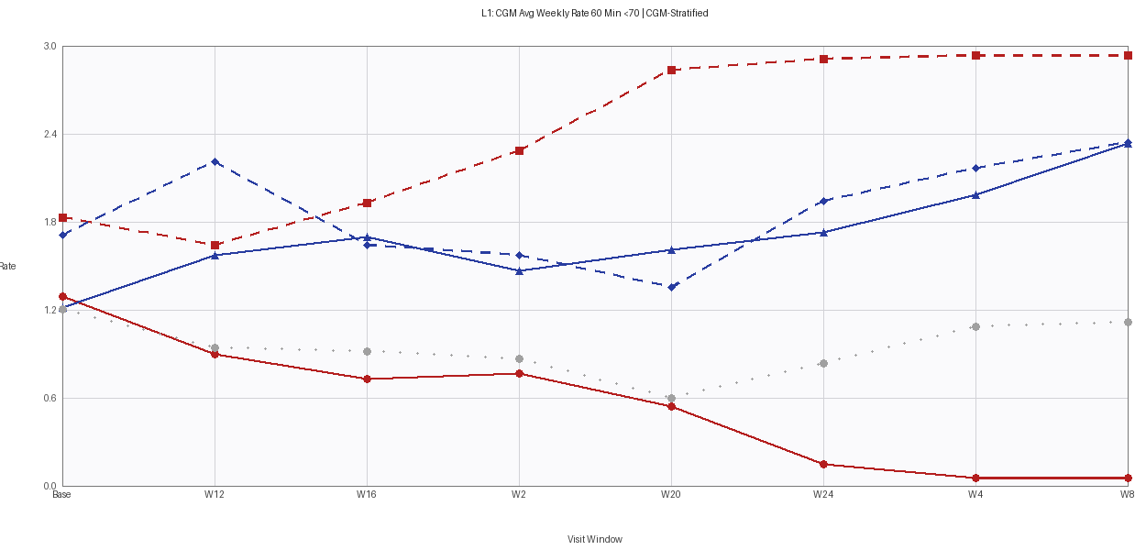

Section 3 — ADAVCG | Figure 14: L1: CGM Avg Weekly Rate 120 Min (<70 mg/dL) | CGM-Stratified
Original Report Figure | Code-Regenerated Figure (Verbatim)
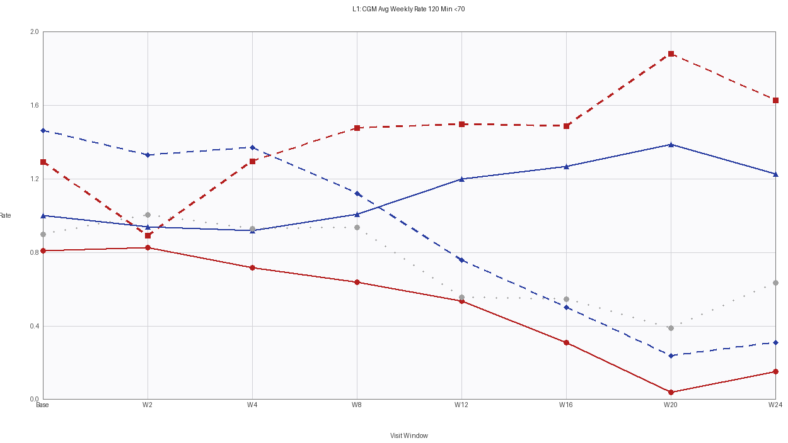 | 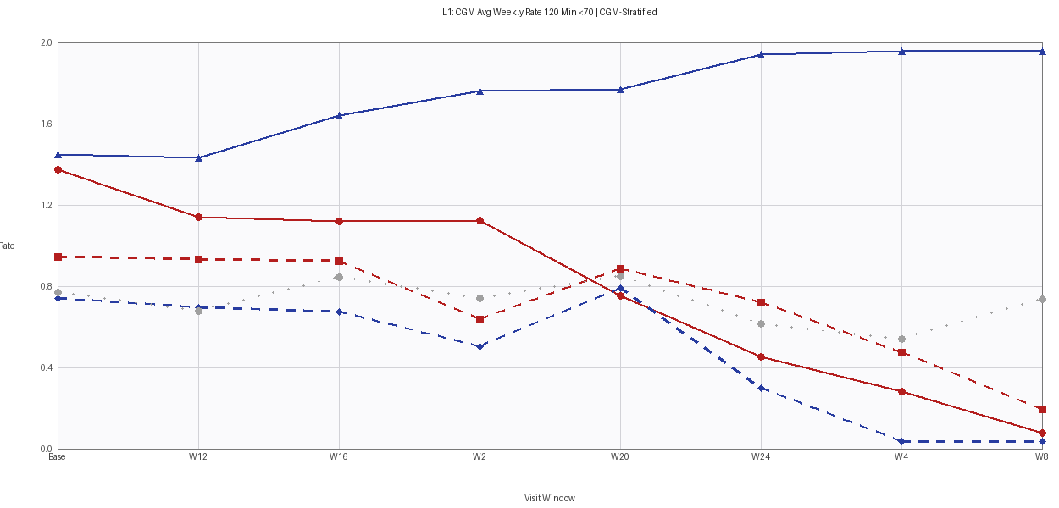

Section 4 — ADBGMI | Figure 15: L1: MI Avg Weekly Rate 30 Min (<70 mg/dL) | CGM-Stratified
Original Report Figure | Code-Regenerated Figure (Verbatim)
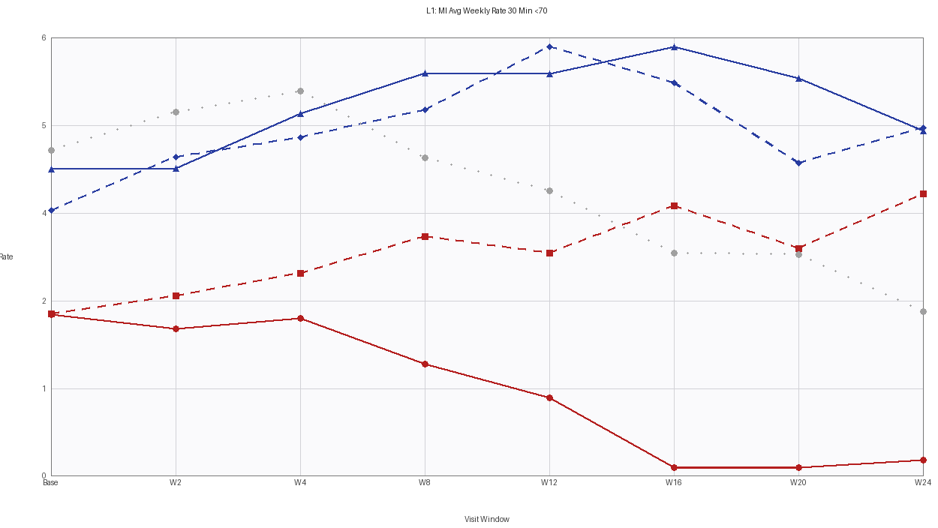 | 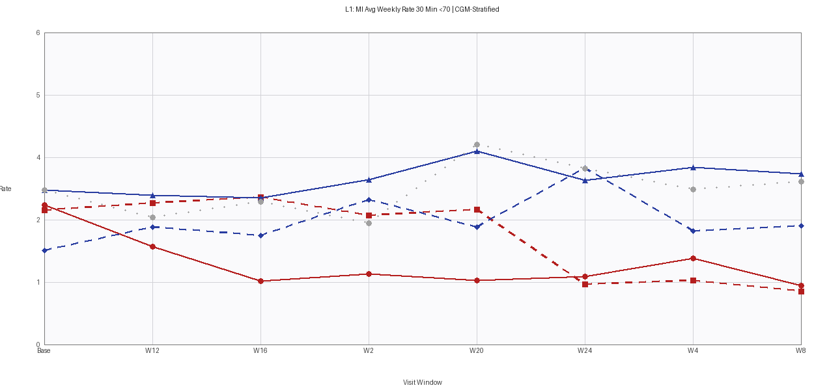

Section 4 — ADBGMI | Figure 16: L1: MI Avg Weekly Rate 60 Min (<70 mg/dL) | CGM-Stratified
Original Report Figure | Code-Regenerated Figure (Verbatim)
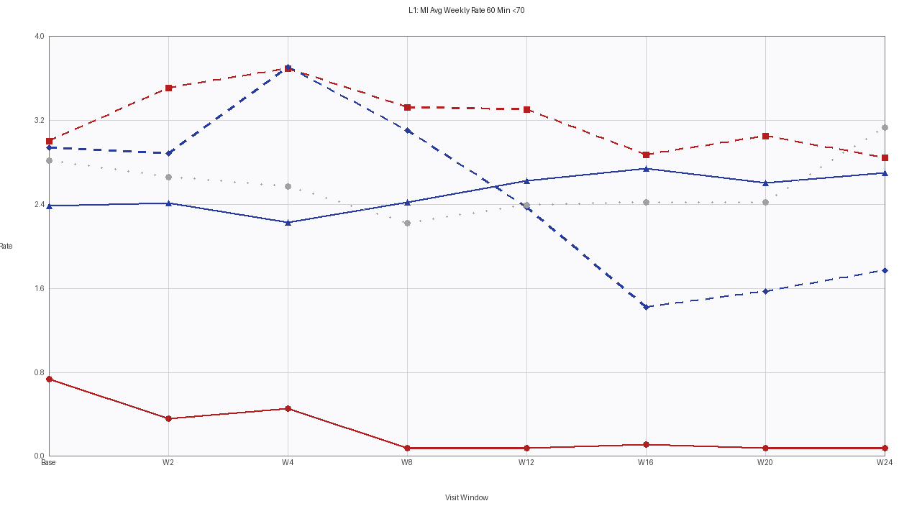 | 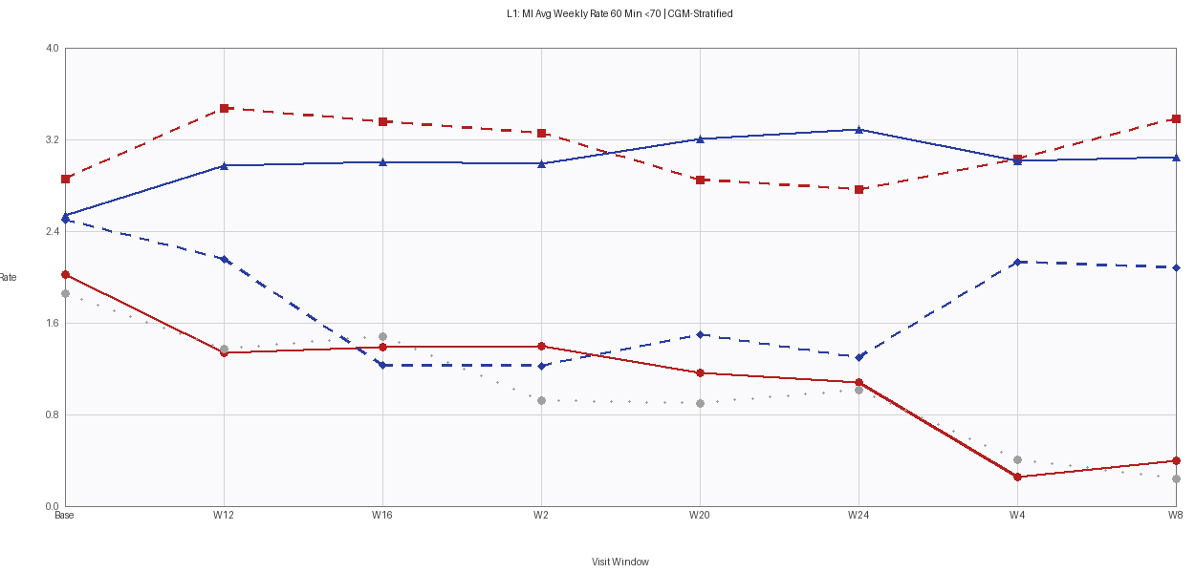

Section 4 — ADBGMI | Figure 17: L1: MI Avg Weekly Rate 120 Min (<70 mg/dL) | CGM-Stratified
Original Report Figure | Code-Regenerated Figure (Verbatim)
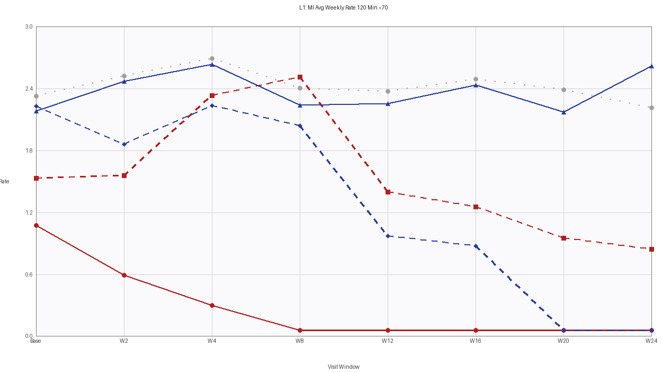 | 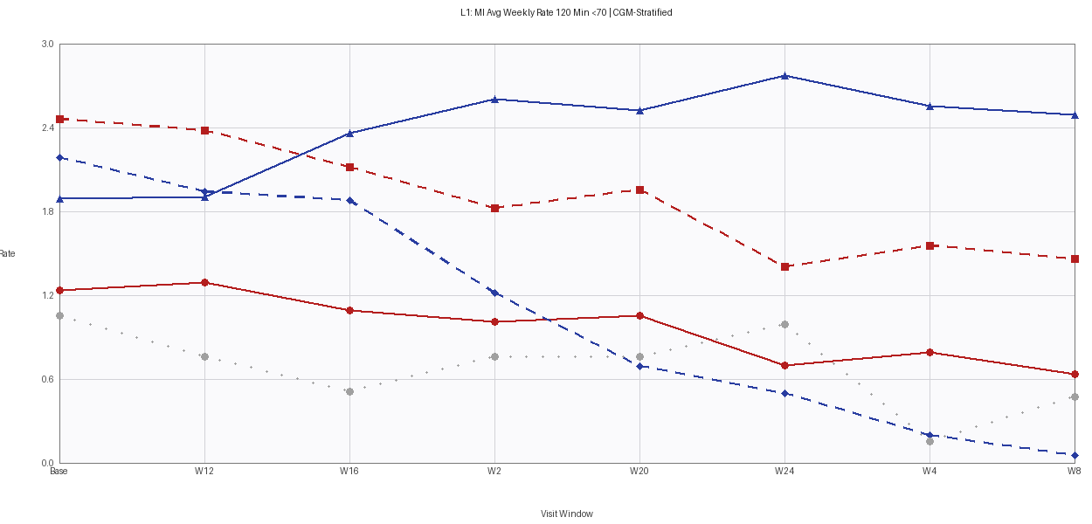

Section 4 — ADBGMI | Figure 18: L2: MI Avg Weekly Rate 30 Min (<54 mg/dL) | CGM-Stratified
Original Report Figure | Code-Regenerated Figure (Verbatim)
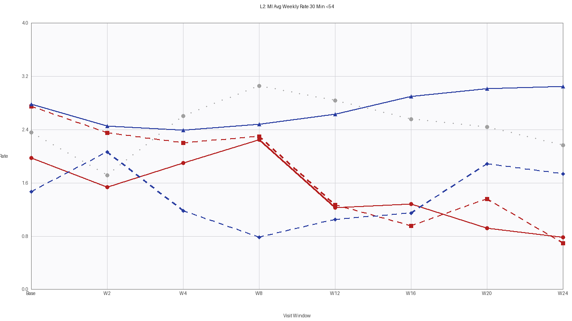 | 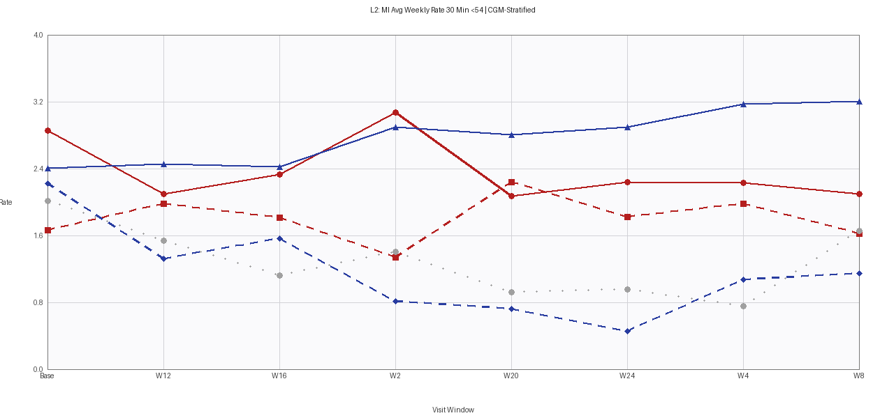

Section 4 — ADBGMI | Figure 19: L2: MI Avg Weekly Rate 60 Min (<54 mg/dL) | CGM-Stratified
Original Report Figure | Code-Regenerated Figure (Verbatim)
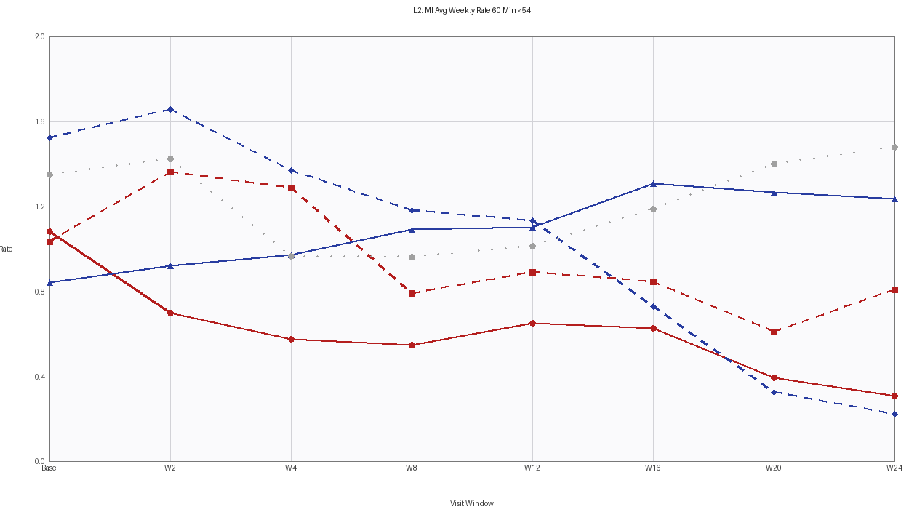 | 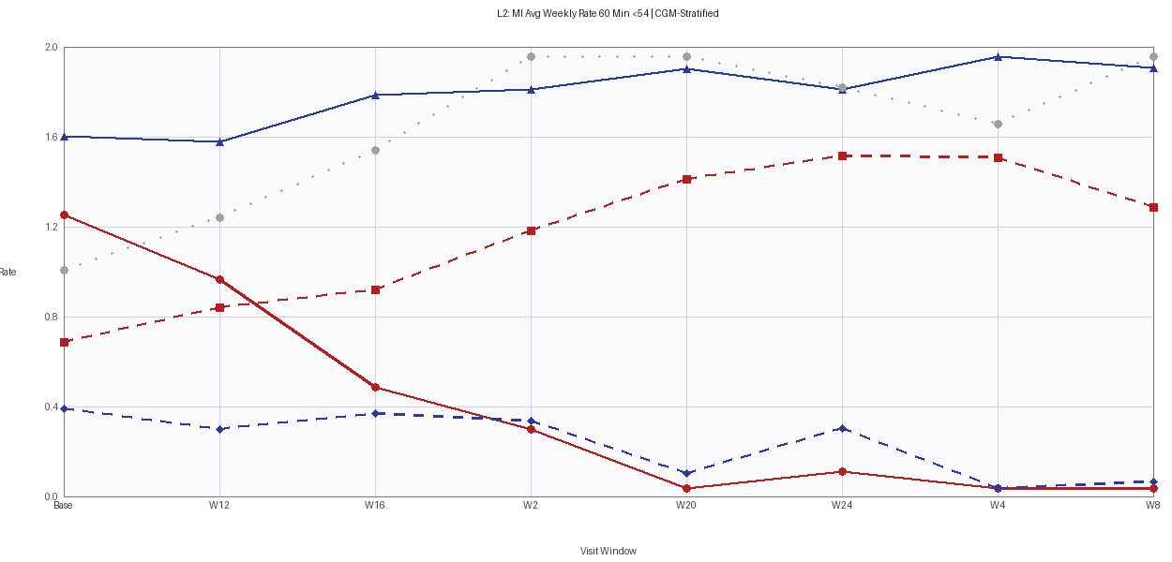

Section 4 — ADBGMI | Figure 20: L2: MI Avg Weekly Rate 120 Min (<54 mg/dL) | CGM-Stratified
Original Report Figure | Code-Regenerated Figure (Verbatim)
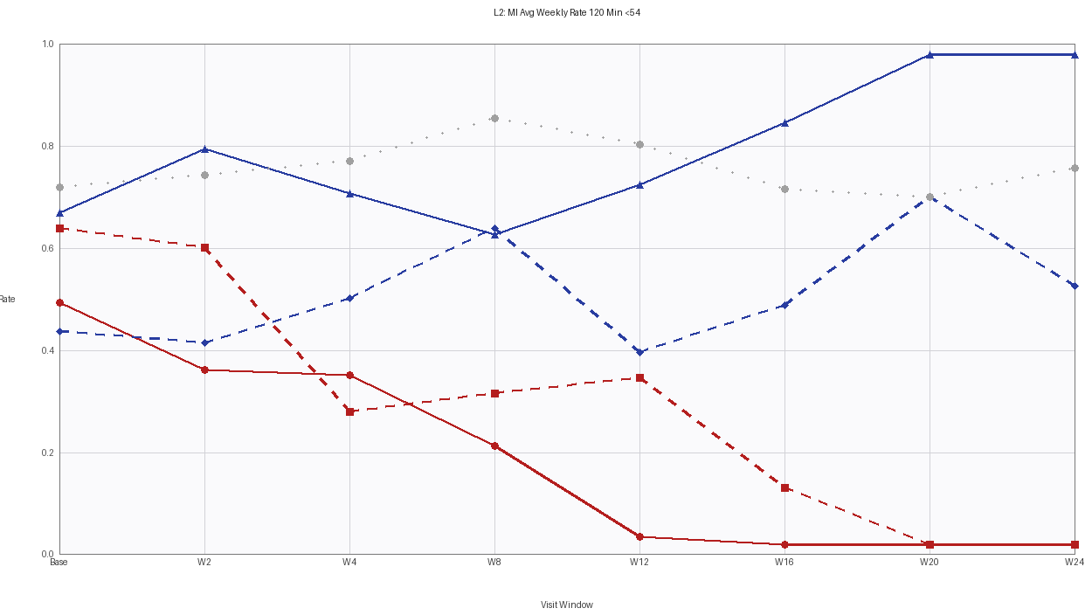 | 

